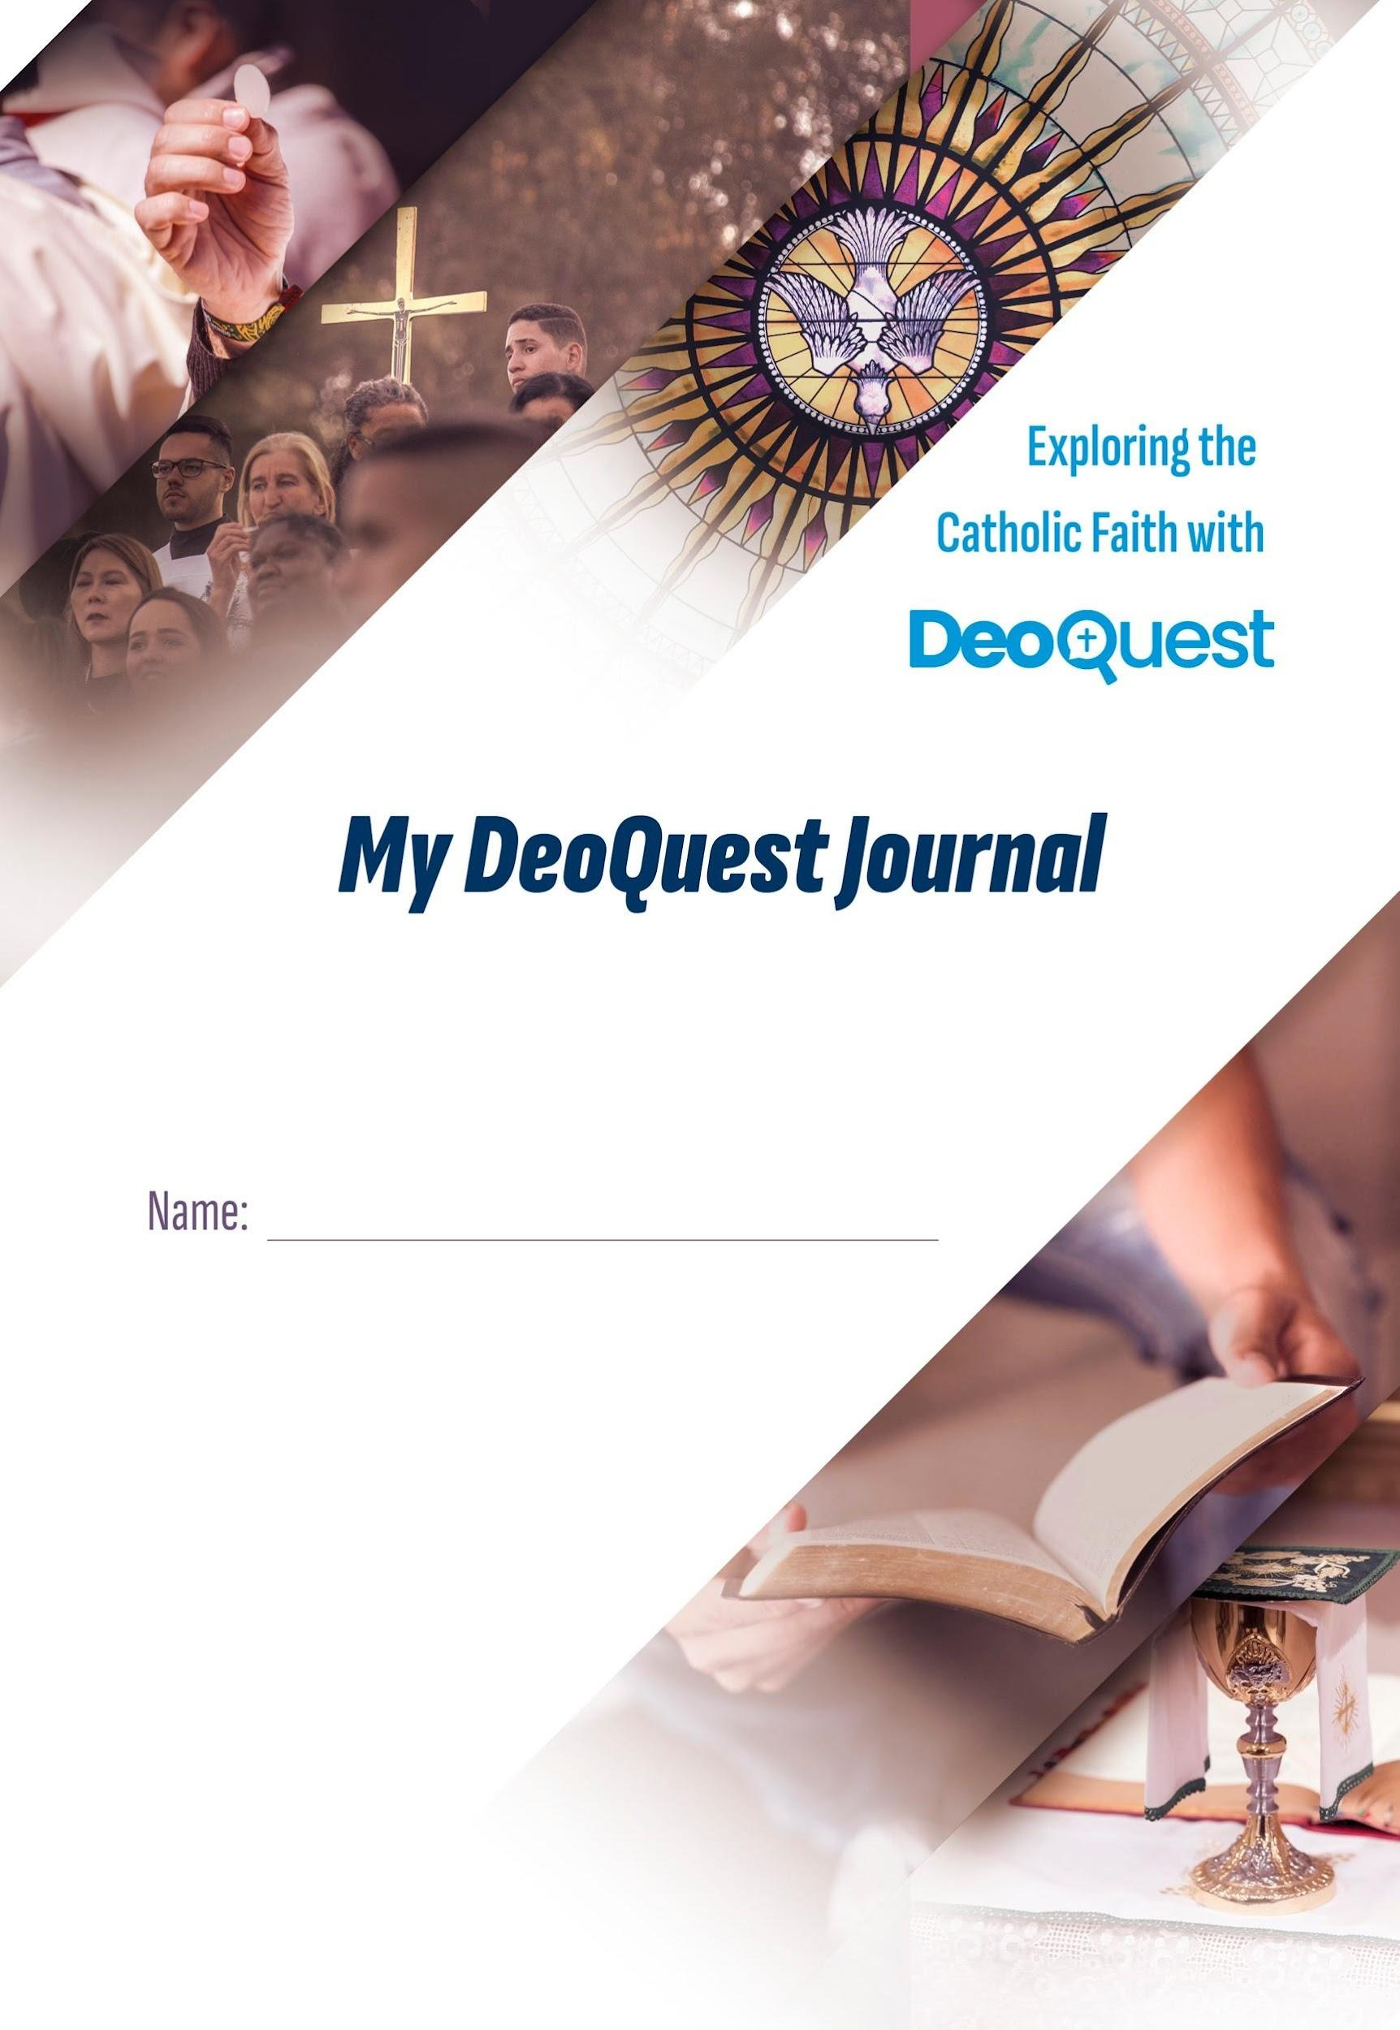
Table of contents

Your Questions matter! 3
My DeoQuest Journal 4
Five DeoQuest ‘rules’ 4
DeoQuest resources 5
1. Science and faith 6
4. Heaven and Earth 9

Your Questions matter!

Welcome to this journey into the Catholic faith! The journey of learning that we will undertake together has been developed by DeoQuest, jointly with … While believing is a personal choice and commitment, all diocesan staff can be expected to have a foundational knowledge and understanding of the beliefs and practices of the Catholic faith.

The DeoQuest approach –
Dare to Relate, Ask, Listen, Think, Believe
DeoQuest’s journey begins with the Questions people are asking about life, God and faith. These Questions are leading on our journey of discovery that we hope will be life-changing for you.

The program and its meetings provide the ‘time and space’ for you and others to ask questions, listen, reflect and learn about the faith, and to pray, act with charity – and celebrate together. We do this as we meet together to:

1. RELATE: The sessions are not just classes, but a place for each participant to grow in relationship with others and God.

2. ASK: Being honest about your questions is the beginning of finding answers. An inquisitive attitude is essential for growing in understanding of the faith. So do not be afraid of your questions and get ready to search for answers together.

3. LISTEN: Listening carefully to each other and especially to what the Church teaches and why will help you to form your own conscience and come to conclusions about what is good, right and true.

4. THINK: Thinking and searching for answers are fundamental for our lives. This is not just an intellectual activity. Let the discoveries become part of your life and see how they call you to action in various ways.

5. BELIEVE: Pray & Act – Believing is optional. Participants are invited to come to a personal conclusion, looking at how what has been said is related to their personal lives. A brief prayer is part of every session.

My DeoQuest Journal
This DeoQuest Journal wants to be a helpful tool and guide on your journey, enabling you to keep a record of your listening, thinking, asking, relating, and learning. It will connect you with the DeoQuest resources that we will use in each session.

It is your personal Journal, and for your eyes only! Keep it somewhere safe. We encourage you to refer to it often as you journey through the program.

We wish you a wonderful journey of discovery as you search, learn and grow in understanding of the Catholic faith! And remember… always dare to Ask, Listen, Think, Relate… and possibly even Believe!

Five DeoQuest ‘rules’
Every participant is invited to join in the conversations on different faith topics. To stimulate the participation of all, it helps to create a welcoming setting where they can share their thoughts without fear of making mistakes, touching on taboos or saying something wrong. Only thus can we progress on our path towards the truth in complete freedom of spirit. The DeoQuest ‘rules’ aim to stimulate the personal search of each participant and respect their freedom.

1. Welcome all questions regarding faith and life, regardless of the position they may represent or the answer they may imply.
2. Listen respectfully to the others in the group and try to understand the reasoning behind their statements.
3. Let the arguments behind the Church’s teaching speak for themselves.
4. Do not try too hard to convince; simply testify to your own faith. Remember that only God can convert people’s hearts.
5. Be discrete: do not discuss what people say with others outside the group.

DeoQuest resources
www.deoquest.com/app



1. Science and faith
Can science and faith logically explain our origin?

# ASK | Today’s Questions
Can science and faith logically explain our origin?
Can I ask questions about the faith? Can I doubt? Doesn’t the Big Bang rule out faith in God? Can science and faith go together?

# THINK | Key takeaway points
- Asking questions helps you engage with the truth (of the faith) and gain insight.
- The Big Bang tells how God created the world and the story of Creation why.
- Science helps to know God’s creation; faith sheds light on the work of science.

# THINK | My notes

# ACT | What does this mean for me?

# ASK | My remaining Questions

# LISTEN | Optional further reading
- Fundamental teaching in Navigating with GOD: 1.1, 1.5, 1.9
- The witness of the Saints in Online with Saints: 1.49
- Catholic Social Teaching in Your neighbour is GOD: 25
- Bible texts:
‘In the beginning when God created the heavens and the earth… God said, ‘Let there be light’; and there was light. And God saw that the light was good… God created humankind in his image, in the image of God he created them; male and female he created them’ (Genesis 1:1.3-4.27).

‘By faith we understand that the worlds were prepared by the Word of God, so that what is seen was made from things that are not visible’ (Hebrews 11:3).

‘Lift up your eyes and look to the heavens: Who created all these? He who brings out the starry host one by one and calls forth each of them by name’ (Isaiah 40:26).



4. Heaven and Earth
How is our death related to Jesus’ resurrection?

# ASK | Today’s Questions
How is our death related to Jesus’ resurrection?
What is the ‘resurrection’ and why is it important? What is heaven like? Is hell real? What is purgatory? Will my soul live forever?

# THINK | Key takeaway points
- The resurrection is God’s promise: if we accept his love we can live with him forever in heaven.
- Our destiny is heaven. Consciously refusing God’s love means choosing hell, far away from all love.
- God and sin are opposites: in his mercy he gave us purgatory to be cleansed and enter heaven.

# THINK | My notes

# ACT | What does this mean for me?

# ASK | My remaining Questions

# LISTEN | Optional further reading
- Fundamental teaching in Navigating with GOD: 1.45, 1.46, 1.47, 1.50
- The witness of the Saints in Online with Saints: 2.24
- Catholic Social Teaching in Your neighbour is GOD: 15
- Bible texts:
‘Jesus said, ‘I am the resurrection and the life. Those who believe in me, even though they die, will live, and everyone who lives and believes in me will never die’ (John 11:2-26).

‘Christ suffered for sins once for all, the righteous for the unrighteous, in order to bring you to God. He was put to death in the flesh, but made alive in the spirit’ (1 Peter 3: 18).

Jesus said, the unrighteous ‘will go away into eternal punishment, but the righteous into eternal life’ (Matthew 25:46).

‘All who are in their graves will hear his voice and will come out—those who have done good, to the resurrection of life, and those who have done evil, to the resurrection of condemnation’ (John 5:28-29).

